**Easy ways to improve your pet’s quality of life**

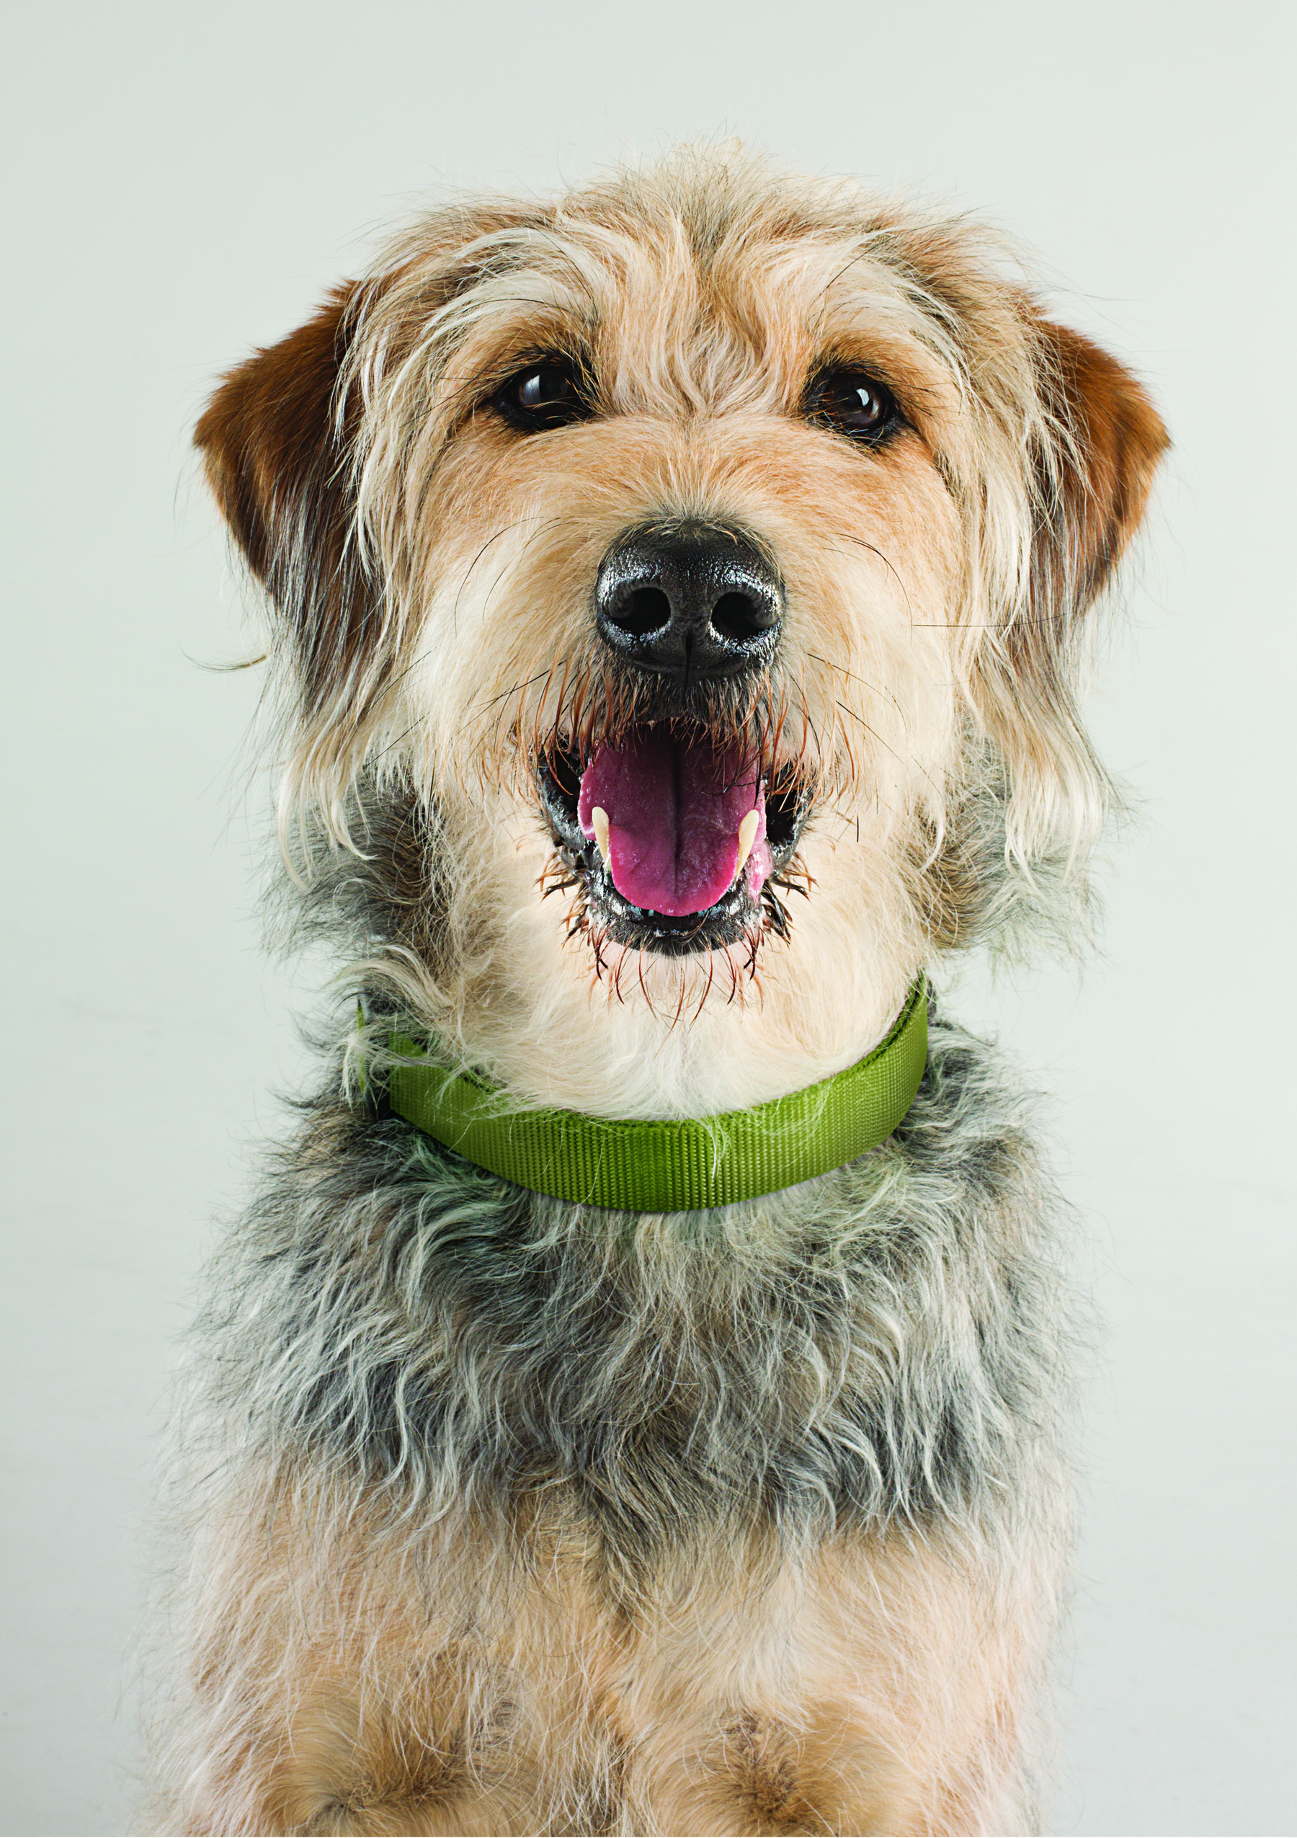Pet ownership is more than just a privilege – it is a responsibility. While pet owners spend ample time and money purchasing elaborate outfits, accessories and toys for their pets, what truly matters is when owners take the initiative to install healthy habits and routines that enhance their pets’ lives.

Across America, veterinarians have witnessed a decline in annual vet visits, resulting in increased rates of preventable diseases in both cats and dogs. In fact, about 54 percent of the nation’s cats and dogs are reported to be obese. As a result, diabetes, heart disease and arthritis are on the rise – diseases that are preventable if identified early on.

“Many pet owners are too busy or just skip annual checkups,” says Ron DeHaven, DVM and chairman for [Partners for Healthy Pets](http://healthypetcheckup.org), a committee of the non-profit American Veterinary Medical Foundation that was created to ensure that pets receive preventive health care. “That’s why we have seen an increase in preventable diseases in cats and dogs. What we need to be sure pet owners realize is that annual veterinary checkups are as important as food and love to a pet’s health and well-being.”

By committing your pet to a healthy routine, you can do your part to ensure they live the happiest, longest life possible. If you want the best for your pet, forget the chevron-striped collar this year and instead focus on these simple tips:

*Schedule annual checkups*

No one knows your pet as well as you do, but veterinarians are trained to detect diseases before they become costly issues for both you and your pet. Make it a habit to schedule an annual checkup for your pet every year, using your pet’s birthday or adoption date as a reminder. There is no better gift you can give to your pet than a long, healthy life and annual checkups are an easy way to ensure your pet is receiving preventive care on a regular basis.

*Provide a proper diet*

You love your pet and your pet loves treats but feeding your pet an excessive amount of food and spoiling them with treats can lead to rapid weight gain. If you are not sure how much you should be feeding your pet, consult your veterinarian. Simple dietary swap-outs can help your pet maintain a healthy weight and decrease the chances of developing health complications.

*Exercise regularly*

It seems like a simple thing to remember. However, busy schedules and daily stresses often cause people to either forget to exercise their pet or move it to the bottom of the to-do list. Commit yourself and your pet to a consistent exercise routine. Only have 10 minutes to take Spot to the park? That’s OK too. Small intervals of exercise each day can make a world of difference long-term.

*Offer love and affection*

Anyone who has loved a pet can testify to the relationship’s emotional benefits. The warm welcome you receive at the front door after a long day at work, the wagging tail you hear as you prepare your pet’s dinner and the head nestled in your lap each night as you watch the news are only some of the rewards of being a dog owner. It is important to reciprocate this love even in small ways, such as a quick scratch behind the ears or tossing a tennis ball around the back yard. Caring for your pet with enduring love and affection will bring you happiness and help enhance your morale daily.